DS PREPROD TEST CLUSTER
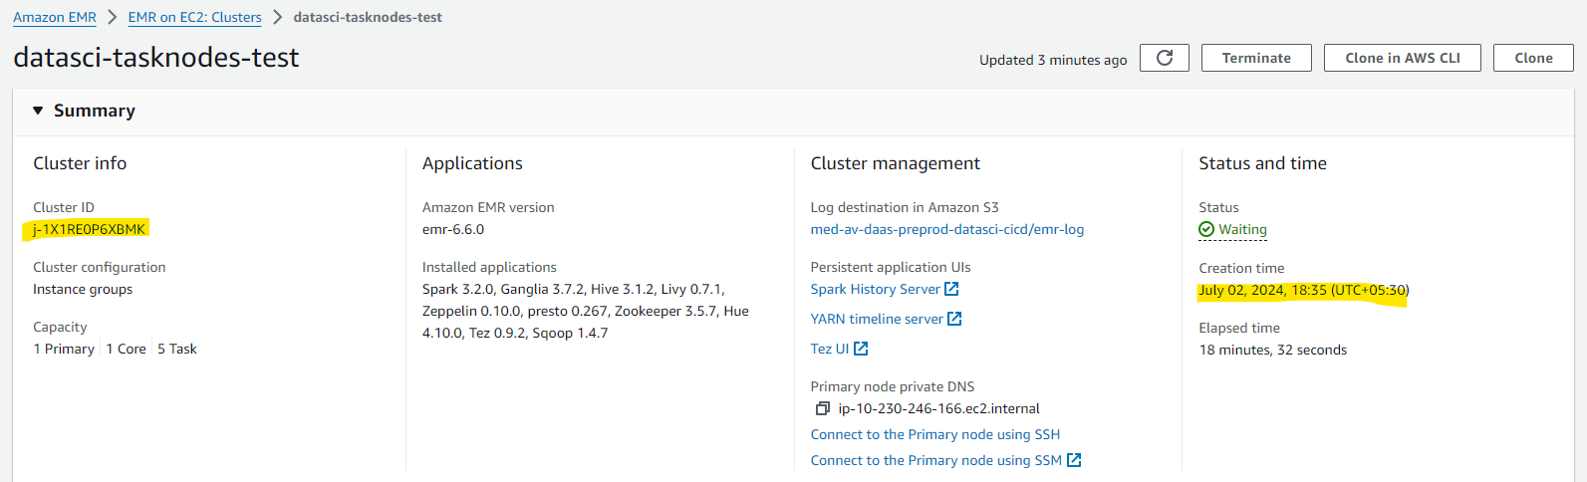
Creation time : July 02, 2024, 18:35 (UTC+05:30)
Cluster came to waiting state after 11 min
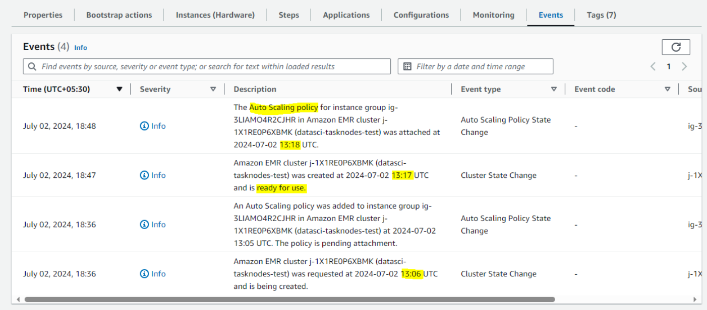
Task nodes also created at the same time of cluster waiting state
Tasknode Ready Time: July 02, 2024, 18:46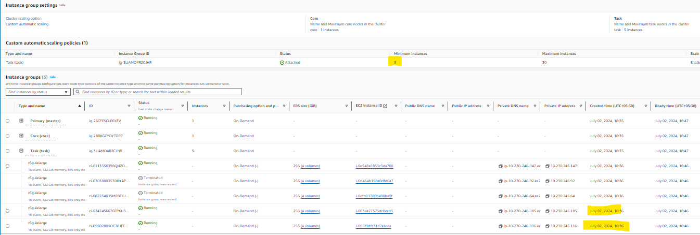
As per the custom auto scaling policy it is ScaleIn from 5 to 3